Set up BroncoDirect for electronic delivery

- At the BroncoDirect/PeopleSoft page, click on "Click here for BroncoDirect/PeopleSoft". Log on with your Bronco ID password.
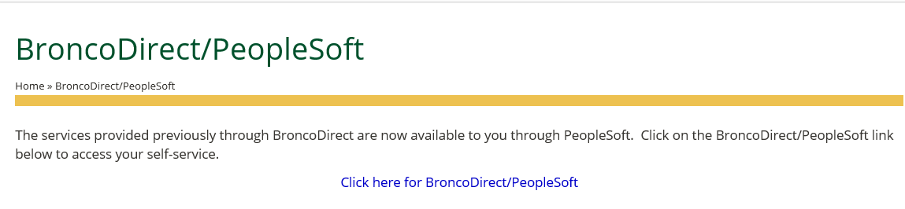

- From the Main Menu, click on BroncoDirect.

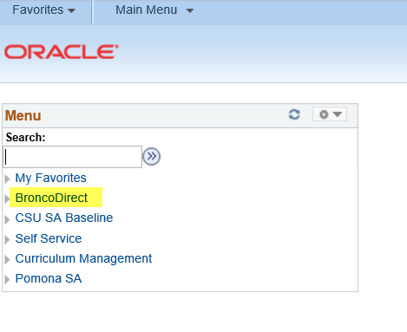

- Click on the Student Center link under Student Self Services section.

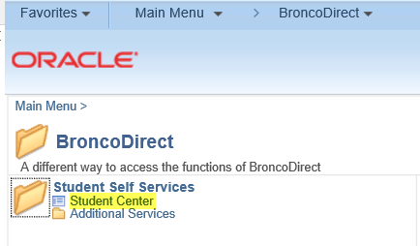

- On the Student Center page, find the Finances section on the left side. On the corresponding drop down box, select View 1098-T and click on the small button next to it.

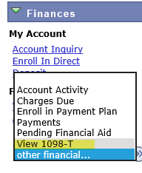

- Click on the Grant Consent button to give consent. The system will allow you to retrieve 1098-T forms this year and in any future years.

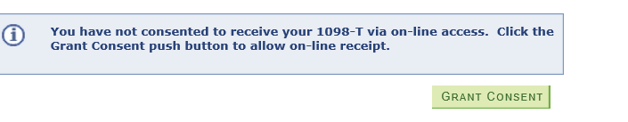

- Check mark the box to confirm the 1098-T Consent Agreement. And click on Submit.

